Emergency Management Plan

for

Insert name of Church/Cathedral
Insert address of Church
Insert suburb of Church

(Insert “hero” photo of Parish Church)

Table of Contents
1. Distribution List 3
2. Amendments 3
3. Glossary 4
4. Emergency Procedure 5
5. Emergency Numbers 6
6. Emergency Contact Information - Parish Personnel 7
7. Parish Profile 9
8. Emergency Management Team (EMT) 10
9. Area Maps and Site Plans 11
Site Plan 12
10. Evacuation plan 13
Recommended Steps for Evacuation 13
Designated Assembly Areas/ Muster Points: 13
11. Parish Emergency Drills / Training Schedule 14
12. Appendices 15
APPENDIX A: Emergency Management Plan Exercise Record 16
APPENDIX B: Post-emergency record 17
APPENDIX C: Bomb threat checklist 18
APPENDIX D: In the event of Fire / Smoke 19
Appendix E: Bushfire Preparedness 20

Distribution List

Plan Rev No. | Revision Name | Copy no. | Issued to: | Date: | Location:
Rev 0 | Draft | 1 |  | --/--/2013 | Vestry/Office
Rev 0 | Draft | 2 |  | --/--/2013
Rev 0 | Draft | 3 |  | --/--/2013
Rev 0 | Draft | 4 |  | --/--/2013
Rev 0 | Draft | 5 |  | --/--/2013 | Insert name of Fire Station 1 or Rural Fire Service
Rev 0 | Draft | 6 |  | --/--/2013 | Insert name of Fire Station 2

Amendments

Plan Rev No. | Revision Name | Reviewed by | Position | Date of Approval | Comment/Reason For change
Rev 0 | Draft | Brendon Lowndes | Property & Risk Officer | 21/08/2013 | Original Document
Rev 1 |  |  |  | 21/08/2015
Rev 2 |  |  |  | 21/08/2017

Glossary
Term | Definition
Emergency Management Plan | The emergency management plan is a document outlining the steps to take in the event of an emergency. It is a legislative requirement to have an emergency management plan and to update it every 2 years or when there is a change to any of the details in the Plan.
Distribution List | The Distribution List is the table of where each copy of the Emergency Management Plan has been located, who it has been issued to and the date it was issued. The regulations state that the Emergency Management Plan must be issued to the two (2) nearest Fire Stations or if in a rural situation to the Nearest Fire Station or Rural Fire Service location.
Amendments | Is the term given to any updates to the Emergency Management Plan brought about by regular reviews. Emergency Management Plans need to be reviewed, by legislation, every 2 years or if there is a change to any of the information included in it. The details of these reviews need to be recorded in the Amendments table above.
Incident | Individual occurrence or event, including dangerous incident, serious injury or illness, a notifiable incident or any other incident that requires a doctor to be seen.
Hazard | Means a situation or thing that has the potential to harm a person. Hazards at work may include: noisy machinery, chemicals, electricity, working at heights, a repetitive job, bullying and violence at the workplace.  It is important when notifying emergency services to inform the operator of any hazards that may be harmful to their personnel on site
Evacuation | Evacuation is the rapid removal of people in a safe and orderly manner from immediate or threatened danger in a workplace.
Evacuation Plan | Is the procedure designed to effectively evacuate all people out of buildings in the case of an emergency
Evacuation Diagram | Is the graphical representation of the building, essential emergency information and the safest means out of the building. The requirements of the Evacuation Diagram are set out in Chapter 10 “Evacuation Diagram”  The evacuation diagram by legislation must be displayed in Churches, Halls, Op Shops and rectories if the rectory is also an office.
Muster Points/ Assembly areas | An area designated for all people to meet in the case of an emergency. The muster points should in themselves be away from any types of hazards in the case of an emergency.

Emergency Procedure

Incident occurs | CALL | 000

 | WHICH | - Which emergency service is required to provide assistance
Advise | LOCATION | - The exact location of the emergency/critical incident
 | TYPE | - The type or nature of the emergency/critical incident.
 | TIME | - The time you became aware of the emergency/critical incident.
 | WHO | - The name/s of persons involved in the incident.  - The number of persons involved in the incident, if available
 | HAZARDS | - If there are any known hazards/hazardous materials still in place at the site of the emergency/critical incident.  - Are there any hazards/hazardous materials adjacent or near the site of the emergency/critical incident.
 | NUMBER | - Number of the person reporting the emergency/critical incident.
 | NAME | - Name of the person reporting the emergency/critical incident.
 | FOLLOW | - Follow all directions of the emergency services personnel given over the phone.
 | CONTACT | Use a different telephone if required and contact;  - The Parish Council Safety Delegate,  - The Anglican Diocese of Newcastle’s WHS Officer,

Report | - Records details of the Emergency or critical incident on the  - If the incident is a Bomb Threat use the Bomb Threat Checklist (Appendix C)

Emergency Numbers

Organisation |  | Phone Number
Police | Critical or life-threatening emergency | 000
 | Non-life threatening incident | 000
 | Local Police Station | (insert local number)
Ambulance | 000
NSW Fire Brigade | 000
 | Name of Local Fire Station 1 | (insert local number)
 | Name of Local Fire Station 1 | (insert local number)
Rural Fire Service | 000
State Emergency Service | 132 500
Hospital(s) | (insert local number)
 | (insert local number)
Gas | (insert local number)
Electricity | (insert local number)
Water Corporation | (insert local number)
Environment Protection Agency: | 9995 5000
Plumber | (Insert name) | (insert local number)
Plumber | (Insert name) | (insert local number)
Electrician | (Insert name) | (insert local number)
Electrician | (Insert name) | (insert local number)
Other: | Add relevant contacts and numbers
Other: | Add relevant contacts and numbers
Other: | Add relevant contacts and numbers

Emergency Contact Information - Parish Personnel

Role | Name | Phone No. (Daytime) | Phone No. (Mobile) | Phone No.  ( After Hours)
Dean/ Parish Priest/Incumbent
Churchwarden
Churchwarden
Churchwarden
Churchwarden
Churchwarden
Parish Council Safety Delegate
Parish Secretary
Parish Treasurer
Mission Secretary
Hall Committee Member
Hall Committee Member
Hall Committee Member
Hall Committee Member
Op Shop Volunteer
Op Shop Volunteer
Op Shop Volunteer
Op Shop Volunteer
Op Shop Volunteer
Op Shop Volunteer
Op Shop Volunteer
Op Shop Volunteer
Op Shop Volunteer
Op Shop Volunteer
Op Shop Volunteer
Op Shop Volunteer
Other

Parish Profile

The Parish profile is a brief description of the Parish, including, how many buildings and rooms are on the property, how many staff, volunteers etc. Include any unique situations or information, such as other tenants, Op Shops, regular Hall users,

PARISH PROFILE SUMMARY
Name of Parish: | Days/Hours of Operation:
Address: | Numbers
 | Parish Roll:
 | Workers with disabilities:
Parish Phone: | Volunteers with disabilities:
Parish Fax: | Staff:
After Hours Emergency Contact: | Name:  Phone:
Name: fill this in only if required
Phone: fill this in only if required
Number of Buildings on Site:
Church | Name: fill this in only if required  Phone: fill this in only if required
Hall: | Name: fill this in only if required  Phone: fill this in only if required
Hall 2: | Name: fill this in only if required  Phone: fill this in only if required
Rectory: | Name: fill this in only if required  Phone: fill this in only if required
Op Shop: | Name: fill this in only if required  Phone: fill this in only if required
Tenant no.1 | Name: fill this in only if required  Phone: fill this in only if required
Tenant no.2 | Name: fill this in only if required  Phone: fill this in only if required
Tenant no.3 | Name: fill this in only if required  Phone: fill this in only if required
Other: | Name: fill this in only if required  Phone: fill this in only if required

Emergency Management Team (EMT)

EMT Members and Tasks

EMT Member | Tasks | Name of staff member  and contact details | Name of ‘Back up’ staff member and contact details
Emergency Controller | In charge of overall management of emergency situation | [Insert name, after hours number and mobile phone number] | [Insert name, after hours number and mobile phone number]
Other EMT Members | Tasks | Name of staff member  and contact details | Name of ‘Back up’ staff member and contact details
[Other} | {Insert tasks] | [Insert name, after hours number and mobile phone number] | [Insert name, after hours number and mobile phone number]
[Other} | {Insert tasks] | [Insert name, after hours number and mobile phone number] | [Insert name, after hours number and mobile phone number]
[Other} | {Insert tasks] | [Insert name, after hours number and mobile phone number] | [Insert name, after hours number and mobile phone number]

Area Maps and Site Plans

A detailed Area Map including the Parishes surrounding area should be included in this document and be made available to your Diocesan office. This map will also be made available to emergency services/response agencies. These maps may be obtained from the internet. The Map should show:

- Muster Points/Assembly Areas | - Evacuation routes
- Surrounding Streets
- Exit points
- The Building/s
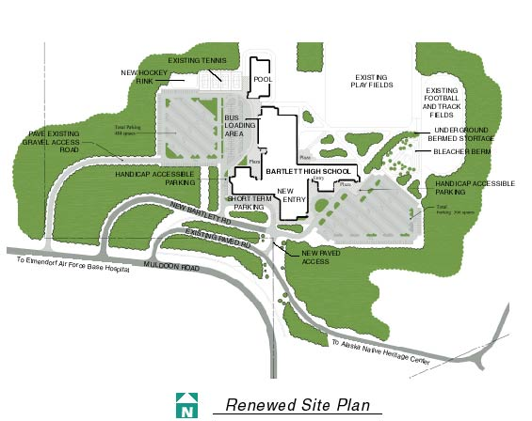
A
A
1km
Est 15 mins
300 metres
Est 5 mins
EXAMPLE ONLY

Evacuation Diagram

Evacuation diagrams are a requirement in all workplaces. The purpose of the evacuation diagram is to:
- Prepare people prior to an emergency by providing a pictorial representation of the Parish and its emergency information,
- Guide people to safety in an emergency,
- Identify location of emergency equipment (alarms, fire extinguishers, fire hose reels, first aid points, warden phones, hydrants, etc...),
- Identify location of emergency and fire exits,
- Identify location of assembly areas and communication points,
- Identify communication and emergency contact information,
- Identify emergency procedures,
- Provide an orientation of where you are.

Evacuation Diagrams must;

- Show a pictorial representation of the floor or area, which shall be at least 200 mm × 150 mm in size.
- Be a minimum size of A4, if you include other information other than the diagram then the minimum size is A3 and the pictorial representation will be A4.
- Be titled “EVACUATION DIAGRAM”
- Show the “You are Here” point
- Show the nearest safe way out from “You are Here” with a path of travel representation
- Show the designated exits OUT of the building shown in GREEN
- Show the telephones, intercoms and communications equipment if any in RED
- Show the manual fire alarm devices if any in RED
- Show the fire fighting equipment in and around the building shown in RED
- Show the Fire Indicator Panel (FIP) if any in RED
- Show the Assembly areas/muster points
- Show the nearest, safest route to the assembly area/muster point from designated exit
- Show a legend
- Individual evacuation diagrams shall have the correct orientation with regard to the direction of egress and its location to the ‘YOU ARE HERE’ point. Where an assembly area diagram is included, the assembly diagram area shall have the same orientation to the rest of the diagram.
- Be displayed in locations where occupants and visitors are able to view the diagrams, if a multi-level building then on each floor of the building
- Be displayed at a height between 1200mm and 1600mm above the finished floor.
- Be in colour
- Show the date that the diagram was completed
- Be as Simple and effective as possible

Sample Evacuation Diagram below-

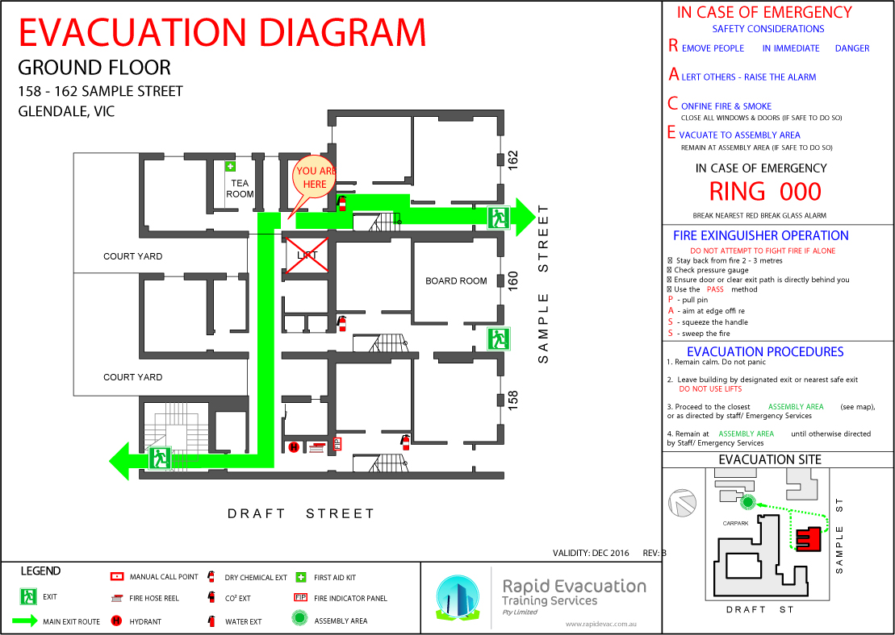

AA

Evacuation plan

Evacuation - Evacuation is the rapid removal of people in a safe and orderly manner from immediate or threatened danger in a workplace.
*** Remember to remain calm and don't panic. ***

Recommended Steps for Evacuation – The Evacuation Plan

- Alert the Emergency Controller/Chief warden and all personnel on site. Emergency Controller/Chief warden takes charge and activates the Emergency Management Team;
- Call 000;
- Follow the Emergency Procedure – as set out in Point “4” above
- If the decision to evacuate is made, using all available workers/volunteers calmly move/carry/walk all parishioners/personnel out of the building to the pre-determined muster point/outdoor assembly area; NOTE: take extra care to help children or mobility impaired people out of the building
- Check all areas are free of personnel only if safe to do so
- Save as many records as possible if it is safe to do so.
- Once at muster point, check all parishioners, volunteers and staff are accounted for;
- Report to the Chief Warden and notify emergency services when they arrive of any people unaccounted for,
- Focus on safety and well-being of parishioners, volunteers and workers,
- Wait for Emergency Services to arrive or for further information.

Designated Assembly Areas/ Muster Points:
- Where you assemble outside the building depends on your Parish Building/s and grounds but it should be at least 150 metres from the nearest building or fire source feature, and be in itself free of hazards.
- You should have 2 Muster Points/Assembly Areas in case the emergency is located near the Primary Muster point.

Parish Emergency Drills / Training Schedule

Months | Training Event | Person Responsible | Date(s) completed
January
February

March
April | Fire Drill
May
June

July
Aug
September
October | Fire Drill
November
December

Appendices

APPENDIX A: Emergency Management Plan Exercise Record
APPENDIX B: Post-emergency Record
APPENDIX C: Bomb threat checklist
APPENDIX D: In case of Fire/Smoke
APPENDIX E: Bushfire Preparedness

APPENDIX A: Emergency Management Plan Exercise Record
Item | Yes | No
Were Emergency Services briefed on exercise prior to exercise being started?
Did the person discovering the “emergency” alert the other occupants?
Was the alarm activated?
Did staff direct persons from the building/site per the evacuation procedures?
Were isolated areas searched?
Was the evacuation logical and methodical?
Did someone take charge? If yes, who?
Did occupants act as per instructions?
Was a roll call conducted for:
Parishioners
Volunteers
Staff/workers
Visitors
Was someone appointed to liaise with the emergency service/s?
Was someone appointed to liaise with the community?
Was the emergency service given the correct information?
Did anyone re-enter the premises before the “all clear” was given?
Did anyone refuse to leave the building/site? If yes, see attached list for name and reason. To be followed up.
Area of Emergency plan tested by current exercise:

APPENDIX B: Post-emergency record

Parish
Date
Time Of Notification
Name Of Person Taking The Call
Position
Name Of Person Reporting The Incident
Contact Telephone Number
Details
Immediate Action | Emergency Controller notified:  YES / NO Time _____  Other staff notified:  YES / NO Time _____  Emergency Services notified:  YES / NO Time ______  Diocesan Office notified:  YES / NO Time ______
Major Activities

Issues | Operational Debriefing Required:  YES / NO Date/Time: _____  Person Responsible to organise:  Confirmation of Operational Briefing:  Date/Time:  Issues for Follow up action:
Signature
Date

APPENDIX C: Bomb threat checklist

CALL TAKER |  | CALL TAKEN
Name |  | Date: | Time:
Telephone # |  | Duration of call
Signature |  | Number of caller
Complete the following for a BOMB THREAT
QUESTIONS | RESPONSES
When is the bomb going to explode?
Where did you put the bomb?
What does the bomb look like?
What kind of bomb is it?
What will make the bomb explode?
Did you place the bomb?
What is your name?
Where are you going?
What is your address?
ACTIONS:
REPORT CALL TO: PHONE NUMBER:
CHARACTERISTICS OF THE CALLER
Sex of caller
Estimated age
Accent if any
Speech impediments
Voice (loud, soft, etc)
Speech (fast, slow etc)
Dictation (clear, muffled, etc)
Manner (calm, emotional, etc)
Did you recognise the voice?
If so, who do you think it was?
Was the caller familiar with the area?

LANGUAGE
[ ] Abusive | [ ] Taped | [ ] Other (Specify)
[ ] Well Spoken | [ ] Irrational
[ ] Incoherent | [ ] Message read by caller

BACKGROUND NOISE
[ ] Music | [ ] Local call
[ ] Machinery | [ ] Long Distance Call
[ ] Aircraft | [ ] Other (specify)

APPENDIX D: In the event of Fire / Smoke

If you see fire or smoke, do not panic or shout.
Remain calm - remember RACE

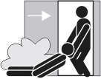
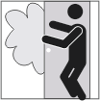
Rescue
- Rescue any people in immediate danger (only if it is safe to do so).

Alarm – Raise the alarm
- ring the Fire Brigades on 000
- notify the Emergency Controller or staff member in charge

Contain
- If practicable, close all doors and windows to contain the fire (only if it safe to do so).

Fire Extinguisher Operation: Fire Extinguisher operation is voluntary, only being used when it is safe to do so. Where practicable, there should be two people in attendance when an extinguisher is being operated. Always ensure you have a safe line of retreat. DO NOT let the fire get between you and the doorway.
Extinguish
- Try to extinguish the fire using appropriate fire fighting equipment- only if you are trained and only if it is safe to do so.
- Select the appropriate extinguisher.

After carrying out R.A.C.E:
- Follow the instructions of your Emergency Controller or Fire Wardens
- Prepare to evacuate if necessary
- Leave the lights on
- Save records if possible

Appendix E: Bushfire Preparedness

All facilities should regularly review their Emergency Management Plans.
Checklist
- Check State Emergency Services (SES) website for current bushfire information
- Determine who is responsible for monitoring fire risk information and how
- Review Emergency Management Plan prior to the official start of the bushfire season
- Allocate roles and responsibilities in executing emergency evacuation procedures
- Regularly inspect the Parish grounds for any items that may become a hazard in the event of a bushfire – long dry grass etc

